Steps to create Application User.

1. Login to CRM Org with a user who has **system admin role**
2. Click on **Settings - > Security** as shown in below image.

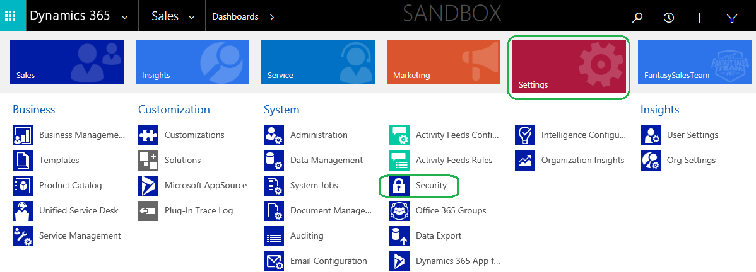

1. Click on **Users** as shown in below image

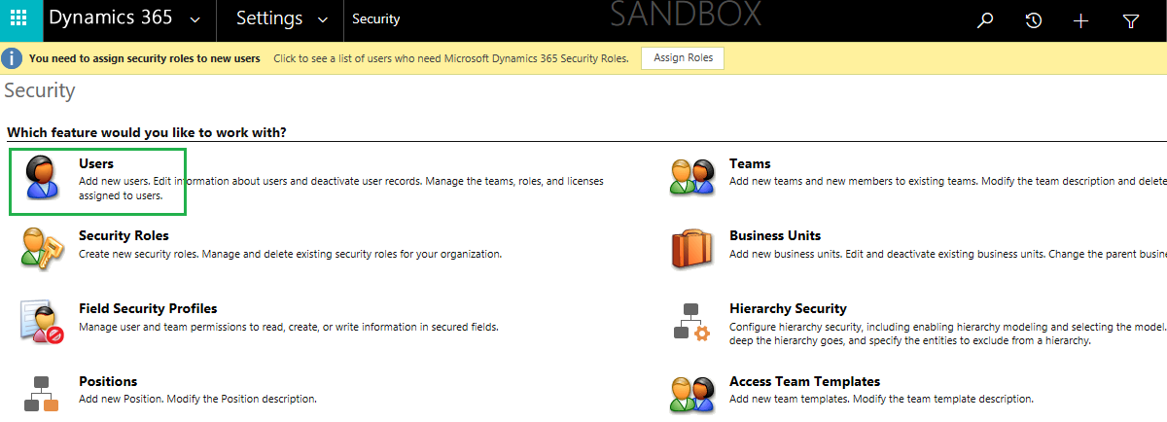

1. Select **Application Users** from the dropdown as shown in below image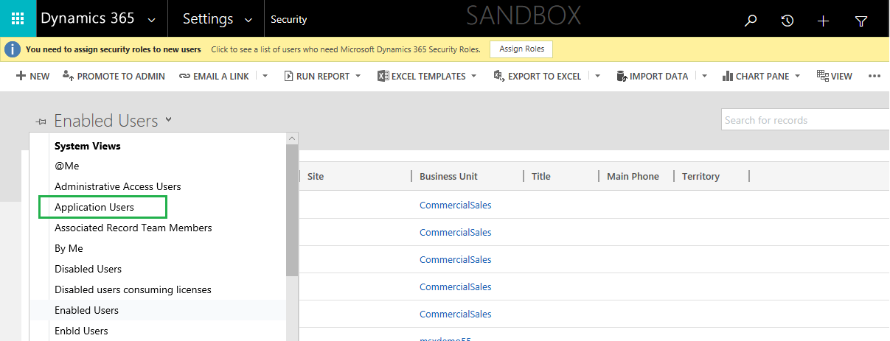
2. Click on **+ New** as shown in below image

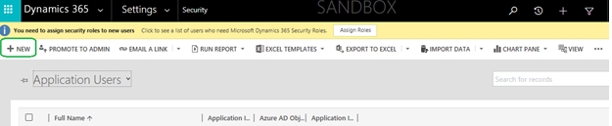

1. Select **Application User** from the Dropdown (if it is not already selected) as shown in below image.

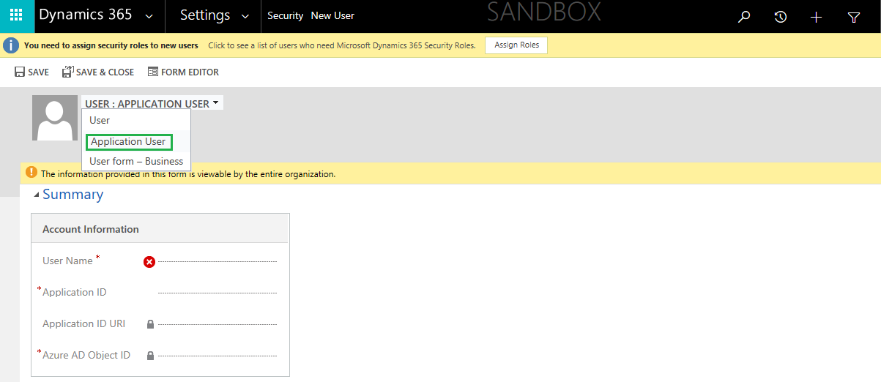

1. Provide details as mentioned below and Save the details

* **Application ID**: Azure Active Directory Web Application ID.
* **Full Name:** Any valid full name. For ex: First Name: Obfuscation & Last Name: Admin
* **Primary Email**: Any valid email. For ex: [dummy@dummy.com](mailto:dummy@dummy.com)

**Note**: User Name, Application ID URI & Azure AD Object ID will get created when user is saved.

1. Select the newly created Application User.

Click on Manage Roles

and grant System Admin role.

